TITLE – KDTree vs QUADTree Analysis

Experiment 1 –
Height of Trees in each experiment has been included in the screenshots of other experiments and not done individually.

- Parameters –
  - Alpha = 50
  - Dataset = A
  - Algorithms used – Kdtree and Quadtree

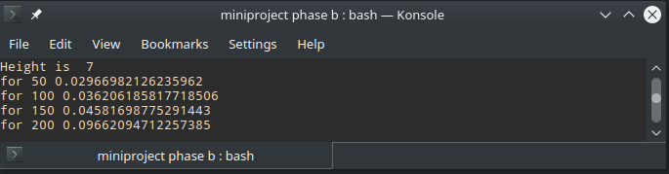
1.1 KD Tree height and running time

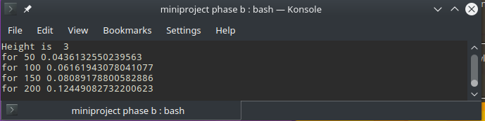
1.2 Quad Tree Height and running time

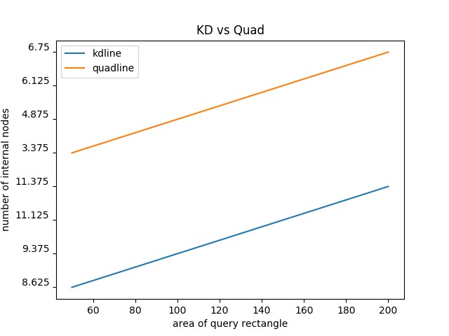
1.3 KD Tree vs Quad Tree Comparison

- Parameters –
  - Alpha = 50
  - Dataset = B
  - Algorithms used – Kdtree and Quadtree

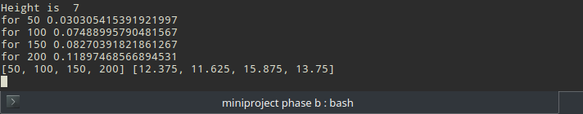
2.1 KD Tree height and running time

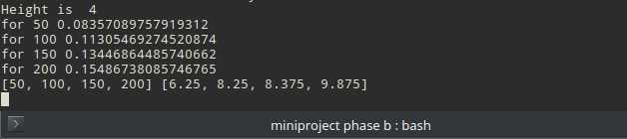
2.2 Quad Tree height and running time

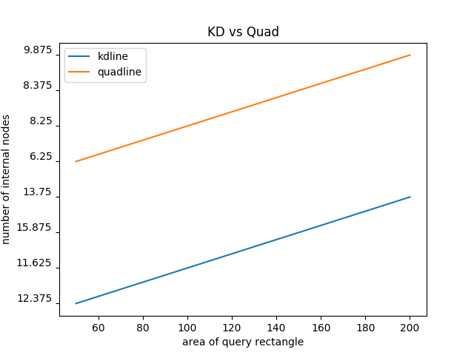
2.3 KD tree vs Quad Tree comparison

- Parameters –
  - Alpha = 50
  - Dataset = C
  - Algorithms used – Kdtree and Quadtree

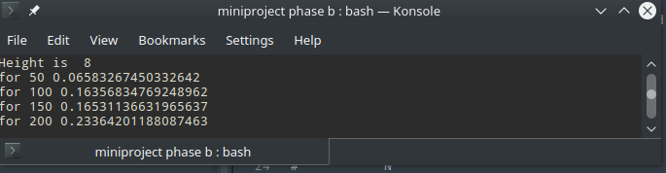
3.1 KD Tree height and running time

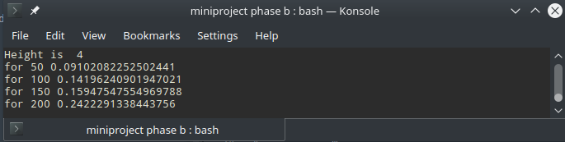
3.2 Quad Tree height and running time

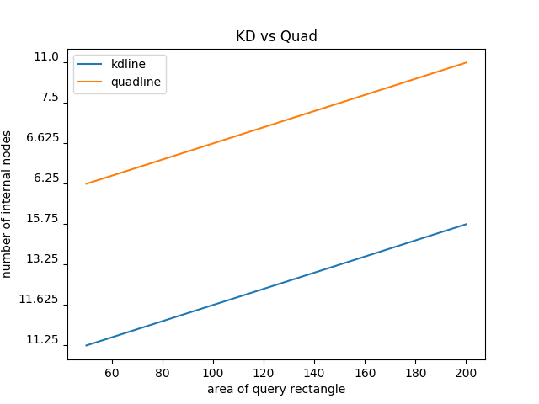
  - KD Tree height vs Quad Tree comparison

EXPERIMENT 2 –

- Parameters –
  - Alpha = 150
  - Dataset = A
  - Algorithms used – Kdtree and Quadtree

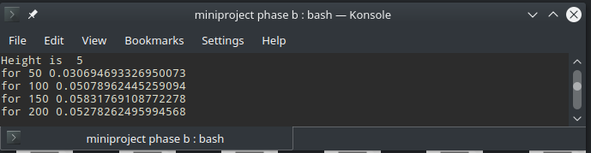
1.1 KD Tree height and running time

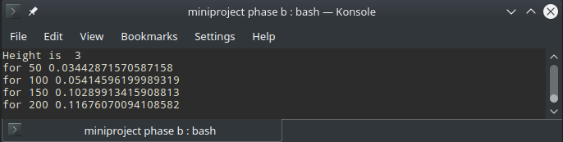
1.2 Quad Tree height and running time

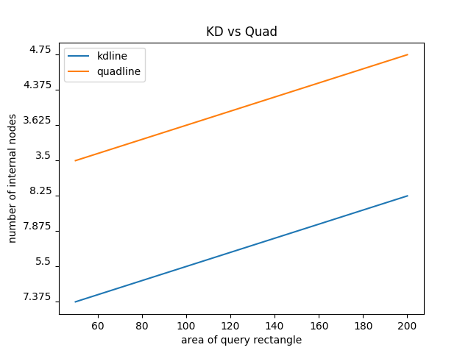
1.3 KD Tree height vs Quad Tree Comparison

- Parameters –
  - Alpha = 150
  - Dataset = B
  - Algorithms used – Kdtree and Quadtree

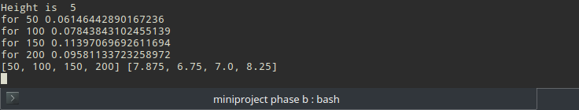
2.1 KD Tree height and running time

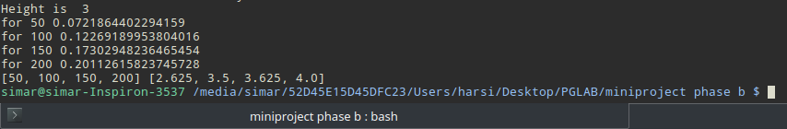
2.2 Quad Tree height and running time

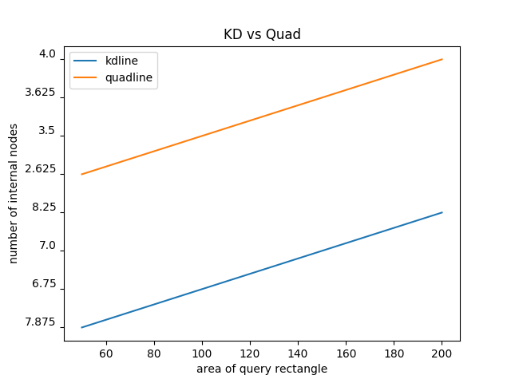
2.3 KD Tree and Quad Tree comparison

- Parameters –
  - Alpha = 150
  - Dataset = C
  - Algorithms used – Kdtree and Quadtree

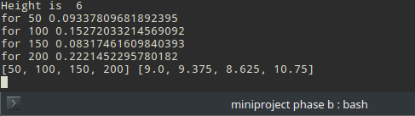
3.1 KD Tree height and running time

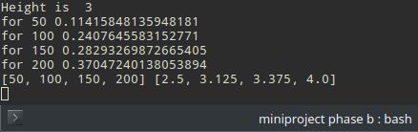
3.2 Quad Tree height and running time
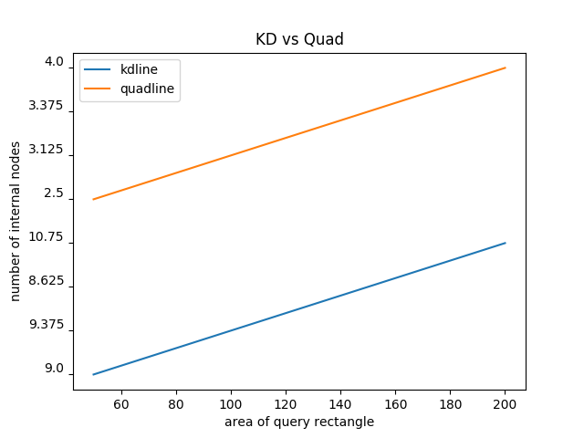
3.3 KD Tree And Quad Tree Comparison
SUBMITTED BY –
Harsimar Singh
2018CSM1010

